NAME : Sharatha sree R COURSE : Mobile Computing
Reg No : 192421033 COURSE CODE: ITA0301

24 . Use Figma to design a flowchart demonstrating the lifecycle of an Android Intent, including explicit and implicit intents.

Aim :
Design a flowchart demonstrating the lifecycle of an Android Intent, including explicit and implicit intents.

Procedure: -
- Open Figma
- Create a new file
- Click on the resources icon and click on the plugins
- Search for the Flow Chart
- Drag and drop the shapes on the screen
- Now, enter the content on the shapes and connect them through Arrows.
- Grouping and alignment
- Review and edit
- Save and share

Design :
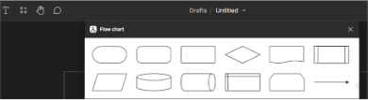

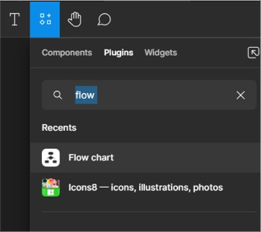
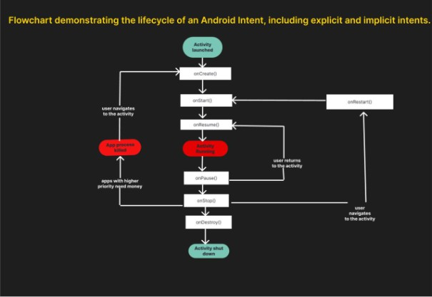

Result :
Hence the flowchart in Figma explaining the lifecycle of an Android Intent, including explicit and implicit intents.

